Logistic Regression

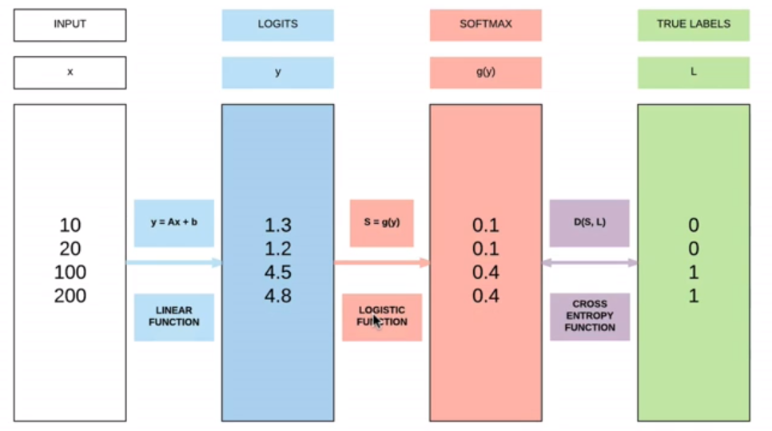

Logits = linear regression

* For linear regression we calculate loss using MSE but for logistic regression we use cross entropy loss

Cross Entropy Loss : Cross-entropy loss, or log loss, measures the performance of a classification model whose output is a probability value between 0 and 1. Cross-entropy loss increases as the predicted probability diverges from the actual label. So predicting a probability of .012 when the actual observation label is 1 would be bad and result in a high loss value. A perfect model would have a log loss of 0.

* Logistic regression is extension of linear regression with addition of softmax function and cross entropy loss function instead of MSE
* minimizing distance between predicted probabilities and labels

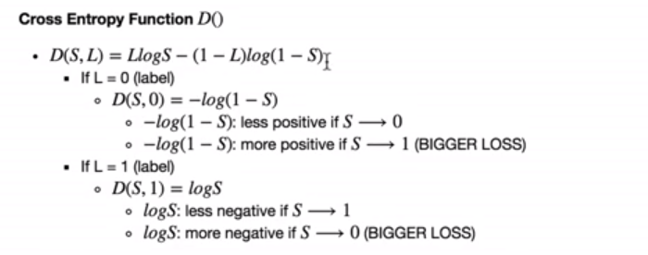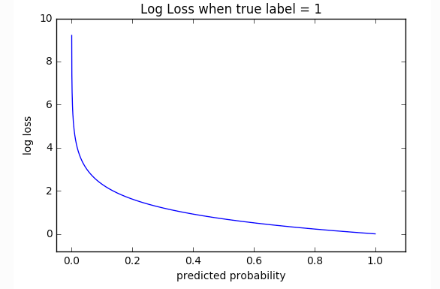

MNIST Dataset

